ATM SOFTWARE SYSTEM

csc 340 ethics and software engineering Individual Project

Lyons, Amber R.

2021

Table of Contents

I. Introduction 2

A. Problem Statement 2

B. Proposal 2

II. System Description 2

III. System Requirements 2

A. Functional Requirements 2

B. Non-functional Requirements 44

IV. Use Case Diagram 45

V. Class Diagram 45

VI. Sequence Diagrams 46

VII. State Diagram 52

VIII. Activity Diagrams 57

IX. Database Design 62

X. Conclusion 64

XI. Data Dictionary 64

# Introduction

## Problem Statement

ZZZ Bank has no ATM machines to serve their customers. They seek out help to develop a software system to provide such service to their customers.

## Proposal

We propose a software system to help the bank set up their ATM service.

# System Description

The system will provide basic operations to customers, including a login, depositing money, withdrawing money, checking balances, and transferring money from one account to another. Each ATM machine will be refilled to hold $100,000 cash daily for possible withdrawals. For security reason, each account can have at most $3000 in total for all the transactions through the ATM machines each day.

# System Requirements

## Functional Requirements

1. The system shall allow a user to login to the ATM machine.
   1. The system shall display a login page to ask the user to enter a card number.

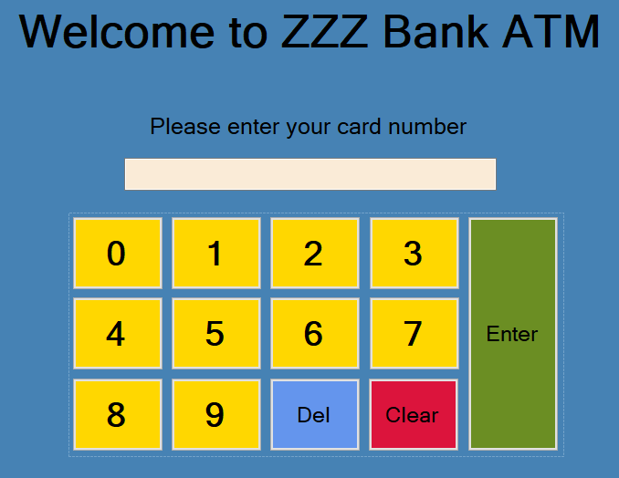

* 1. The user shall input his/her card number.

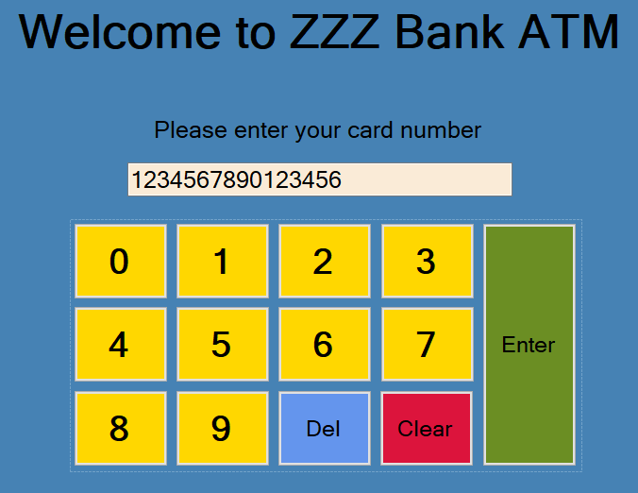

* 1. The system shall display another page to ask the user to enter his/her PIN number.

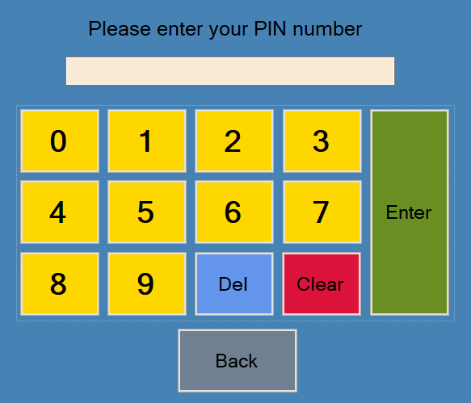

* + 1. If the customer selects the “Back” button, the system shall go back to Step 1.1.



* 1. The user shall enter his/her PIN number.

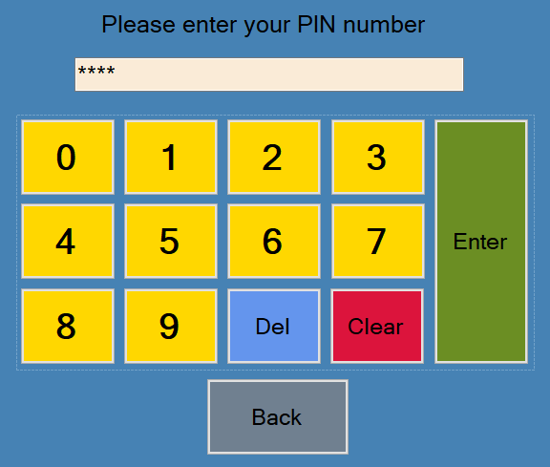

* 1. The system shall validate the card number with the PIN number.
     1. The system shall check if the PIN entry satisfies the NR10.
        1. If the user has already entered the PIN associated with the card number 5 or more times incorrectly, the system shall display an error message and go back to Step 1.1.

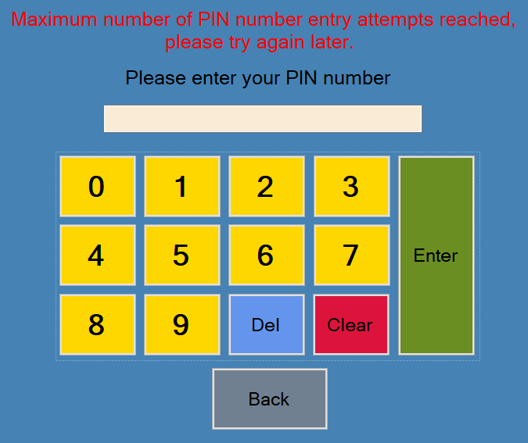



* + - 1. If the user has not entered the PIN associated with the card number 5 or more times incorrectly, the system shall check if the card number matches the PIN number.
         1. If the card number matches the PIN number, the system shall display a main menu.

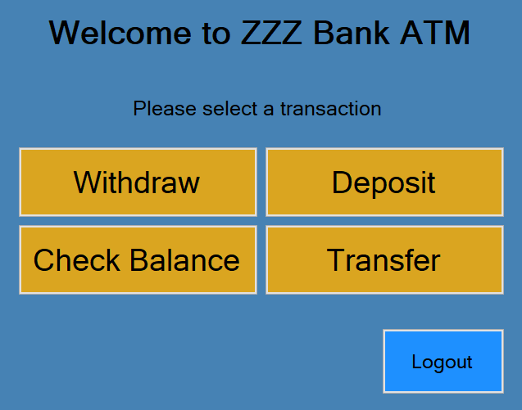

If the customer selects the “Log Out” button from the main menu, the system shall log the customer out of the ATM and display a “Thank you” screen.

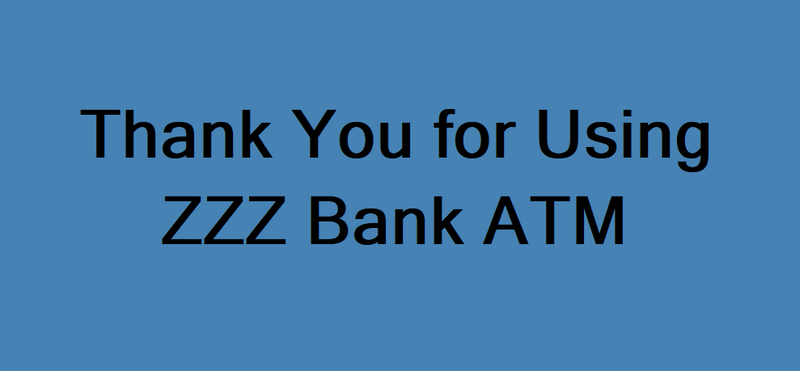

* + - * 1. If the card number doesn’t match the PIN number, the system shall display a certain error message.

The system shall check if the number of invalid PIN entry attempts for the card number satisfies the NR10.

If the number of invalid PIN number entry attempts is greater than or equal to 5, the system shall display an error message telling the user they have reached the maximum number of attempts and go back to Step 1.1.





If the number of invalid PIN number entry attempts is less than 5, the system shall display an error message telling the user that the PIN number is invalid and go back to Step 1.3.

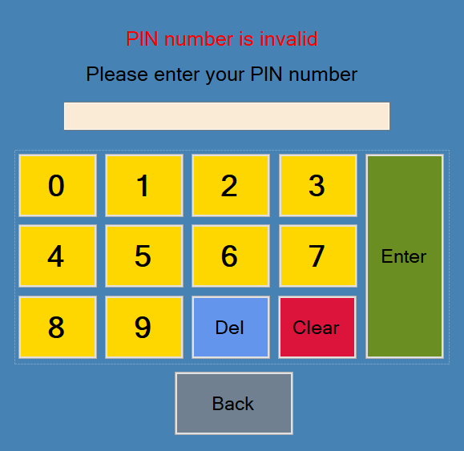



1. The system shall allow a customer to withdraw money from his/her bank account.
   1. The system shall display a main menu screen to the customer.



* + 1. If the customer selects the “Logout” button, the system shall log the customer out of the ATM and display a “Thank you” screen.



* 1. The customer shall select the “Withdraw” button from the main menu.

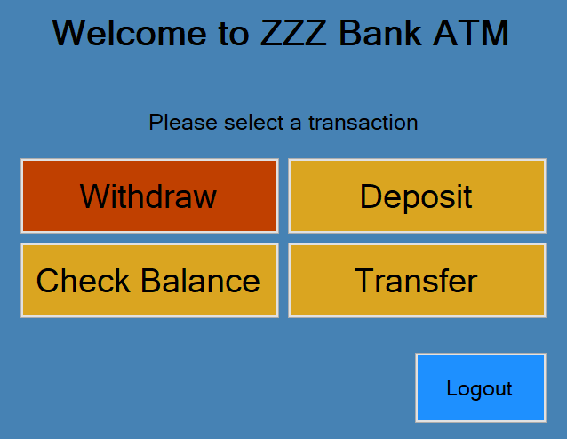

* 1. The system shall display a list of the customer’s accounts available for withdrawal.

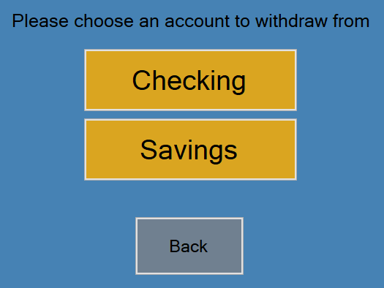

* + 1. If the customer selects the “Back” button, the system shall go back to Step 2.1.



* 1. The customer shall select an account from the list for withdrawal.

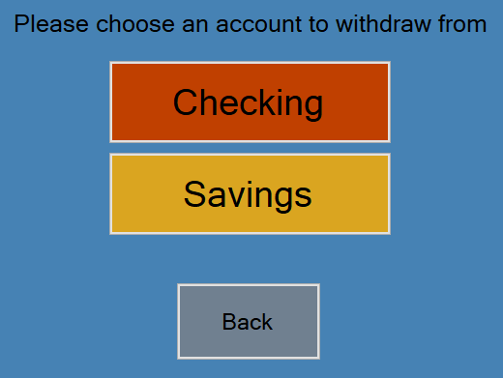

* 1. The system shall display the selected account’s information including the account number and current balance. The system shall ask the customer to enter the amount for withdrawal.

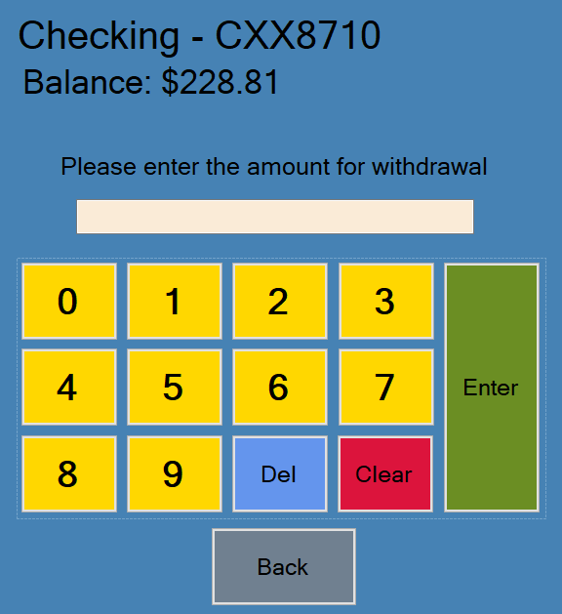

* + 1. If the customer selects the “Back” button, the system shall go back to Step 2.3.



* 1. The customer shall enter the amount for withdrawal.

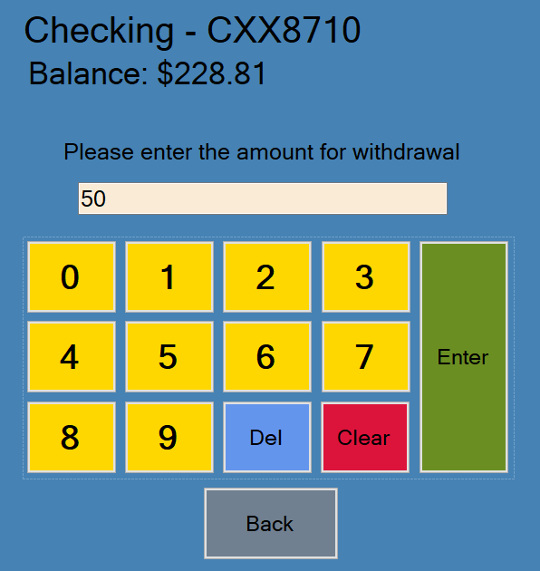

* 1. The system shall check if the withdrawal amount satisfies the NR1.
     1. If the withdrawal amount is greater than $3,000, the system shall display an error message to the customer and go back to Step 2.5.

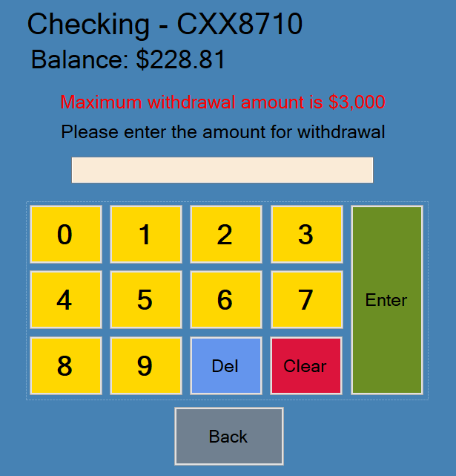



* + 1. If the withdrawal amount is less than or equal to $3,000, go to Step 2.8.
  1. The system shall check if the withdrawal amount satisfies the NR2.
     1. If the difference of the current balance and the withdrawal amount is less than $5, the system shall display an error message to the customer and go back to Step 2.5.

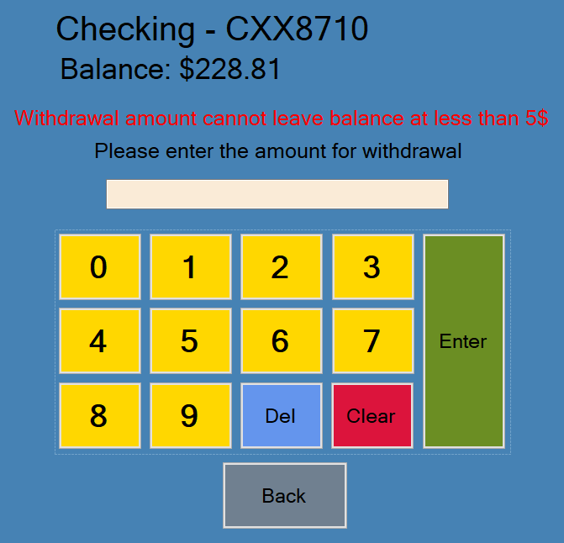



* + 1. If the difference of the current balance and the withdrawal amount is greater than or equal to $5, go to Step 2.9.
  1. The system shall check if the withdrawal amount satisfies the NR3.
     1. If the withdrawal amount is greater than the current amount of available funds inside the ATM, the system shall display an error message to the customer and go back to Step 2.5.

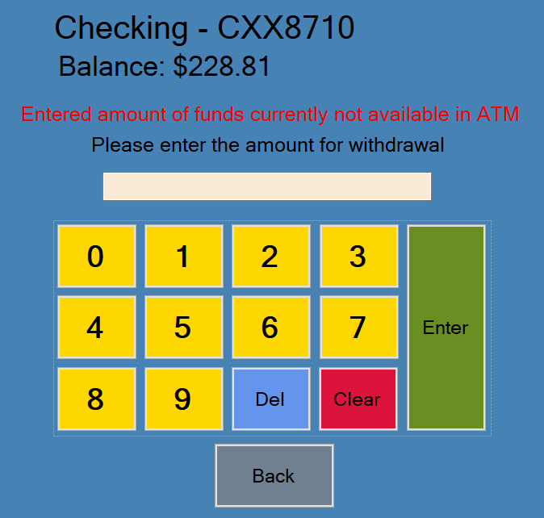



* + 1. If the withdrawal amount is less than or equal to the current amount of available funds inside the ATM, go to Step 2.10.
  1. The system shall check if the withdrawal amount satisfies the NR6.
     1. If the withdrawal amount plus any other withdrawal amounts made to the account during the current day come to a total greater than $3,000, the system shall display an error message to the customer and go back to Step 2.5.

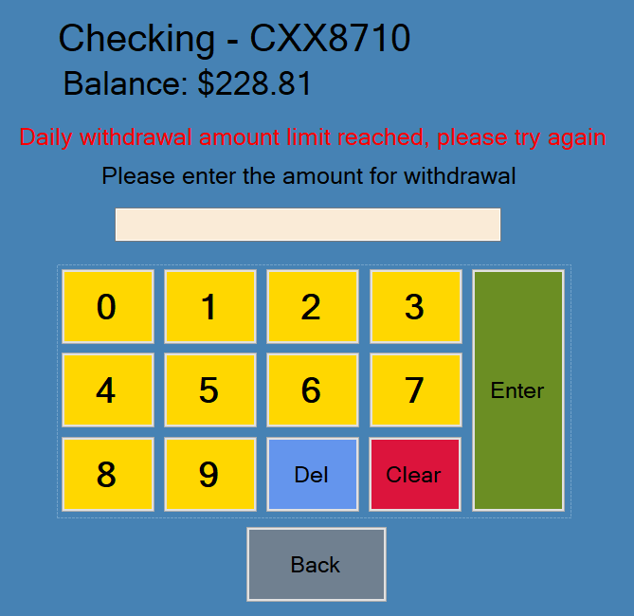



* + 1. If the withdrawal amount plus any other withdrawal amounts made to the account during the current day come to a total less than or equal to $3,000, go to Step 2.11.
  1. The system shall check if the withdrawal amount satisfies the NR11.
     1. If the withdrawal amount is less than 5$, the system shall display an error message and go back to Step 2.5.

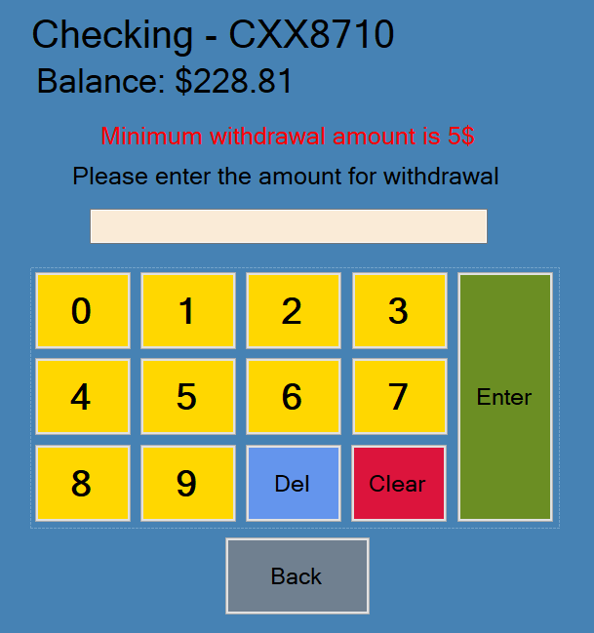



* + 1. If the withdrawal amount is greater than or equal to 5$, go to Step 2.12.
  1. The system shall dispense the money to the customer.
  2. The customer shall take the money from the cash dispenser.
  3. The system shall record the transaction to the database.
  4. The system shall deduct the amount from the account’s current balance and display the new balance to the customer.

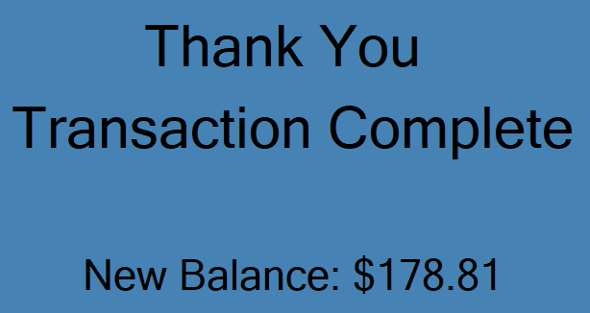

* 1. The system shall deduct the amount from the ATM’s available funds.
  2. The system shall display a menu asking the customer if they want to make another transaction.

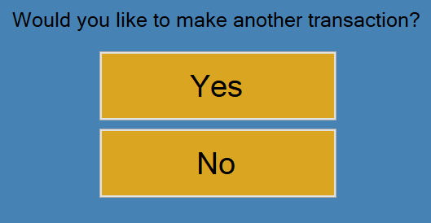

* + 1. If the customer selects the “Yes” button, the system shall return to the main menu screen.



* + 1. If the customer selects the “No” button, the system shall log the customer out of the ATM and display a “Thank you” screen.



1. The system shall allow a customer to deposit money into his/her bank account.
   1. The system shall display a main menu screen to the customer.



* + 1. If the customer selects the “Logout” button, the system shall log the customer out of the ATM and display a “Thank you” screen.



* 1. The customer shall select the “Deposit” button from the main menu.

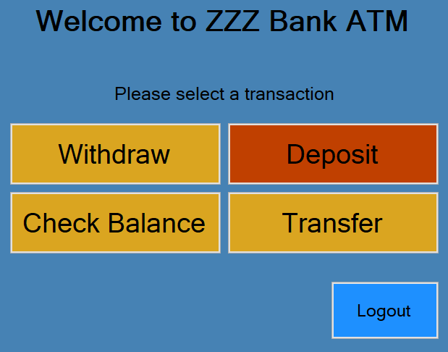

* 1. The system shall display a list of the customer’s accounts available for deposit.

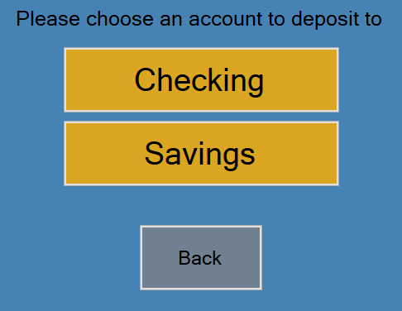

* + 1. If the customer selects the “Back” button, the system shall go back to Step 3.1.



* 1. The customer shall select an account from the list for deposit.

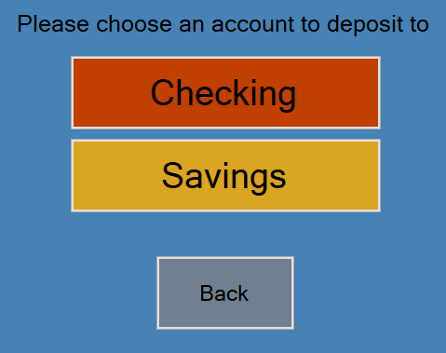

* 1. The system shall display the selected account’s information including the account number and current balance. The system shall ask the customer to enter the amount for deposit.

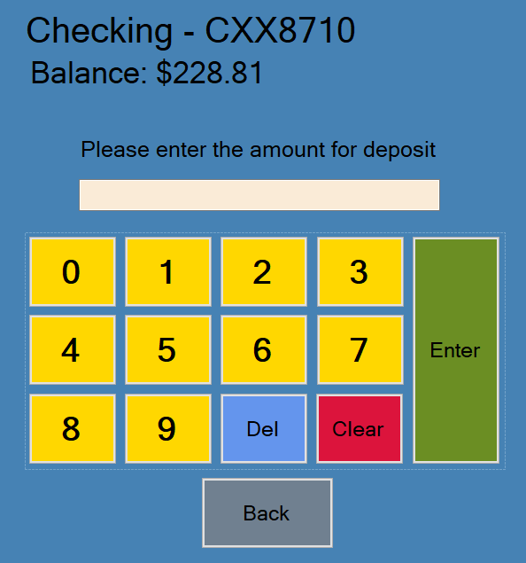

* + 1. If the customer selects the “Back” button, the system shall go back to Step 3.3.



* 1. The customer shall enter the amount for deposit and put the money they want to deposit into the cash receptacle.

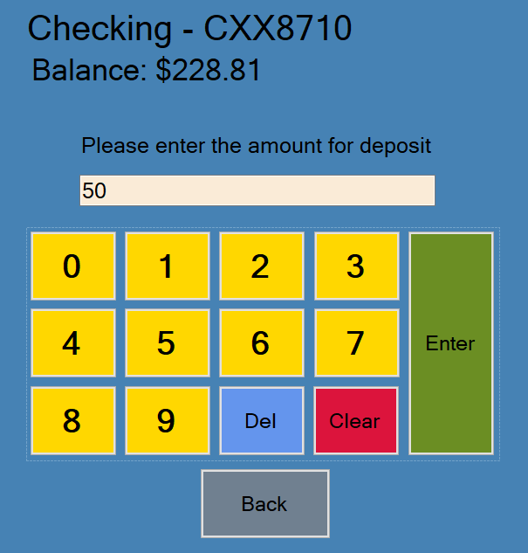

* 1. The system shall check if the deposit amount satisfies the NR4.
     1. If the deposit amount is greater than $3,000, the system shall display an error message to the customer and go back to Step 3.5.

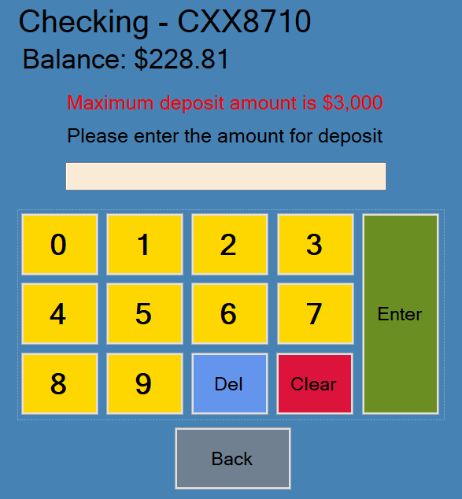



* + 1. If the deposit amount is less than or equal to $3,000, go to Step 3.8.
  1. The system shall check if the deposit amount satisfies the NR5.
     1. If the deposit amount plus any other deposit amounts made to the account during the current day come to a total greater than $3,000, the system shall display an error message to the customer and go back to Step 3.5.

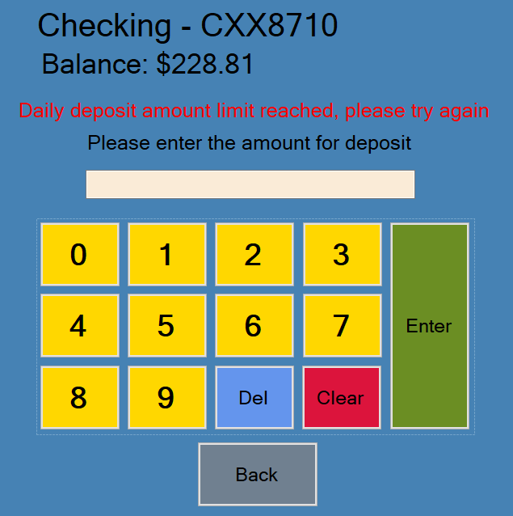



* + 1. If the deposit amount plus any other deposit amounts made to the account during the current day come to a total less than or equal to $3,000, go to Step 3.9.
  1. The system shall check if the deposit amount satisfies the NR12.
     1. If the deposit amount is less than 5$, the system shall display an error message and go back to Step 3.5.

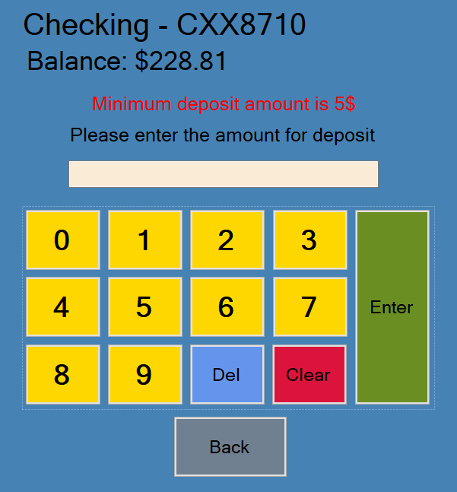



* + 1. If the deposit amount is greater than or equal to 5$, go to Step 3.10.
  1. The system shall record the transaction to the database.
  2. The system shall add the amount to the account’s current balance and display the new balance to the customer.

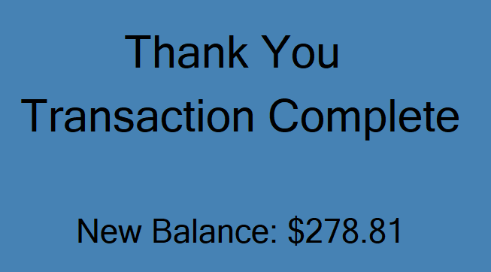

* 1. The system shall add the amount to the ATM’s available funds.
  2. The system shall display a menu asking the customer if they want to make another transaction.



* + 1. If the customer selects the “Yes” button, the system shall return to the main menu screen.



* + 1. If the customer selects the “No” button, the system shall log the customer out of the ATM and display a “Thank you” screen.



1. The system shall allow a customer to view his/her current bank account balance.
   1. The system shall display a main menu screen to the customer.



* + 1. If the customer selects the “Logout” button, the system shall log the customer out of the ATM and display a “Thank you” screen.



* 1. The customer shall select the “Check Balance” button from the main menu.

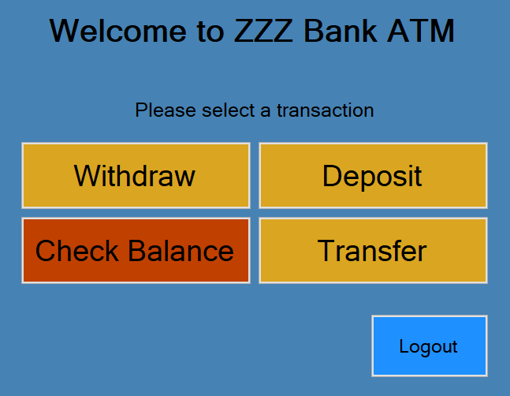

* 1. The system shall display a list of the customer’s accounts to check the balances of.

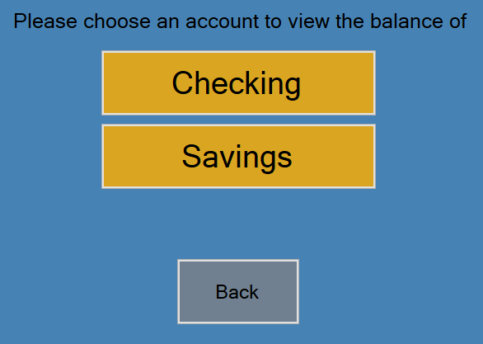

* + 1. If the customer selects the “Back” button, the system shall go back to Step 4.1.



* 1. The customer shall select an account from the list to check the balance of.

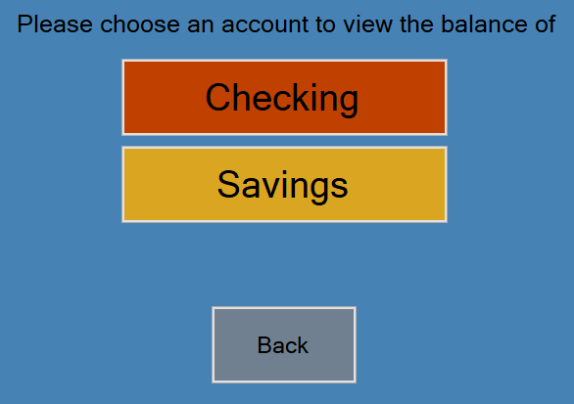

* 1. The system shall display the selected account’s information including the account number and current balance and an “OK’ button for the customer to select after they have viewed the account information.

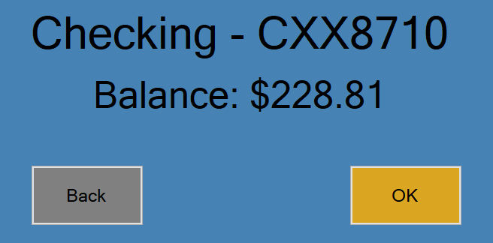

* + 1. If the customer selects the “Back” button, the system shall go back to Step 4.3.



* 1. The customer shall view their account balance and then select the “OK” button when they are done.

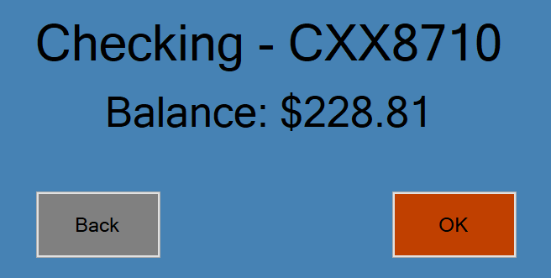

* 1. The system shall display a menu asking the customer if they want to view another account’s balance or make another transaction.

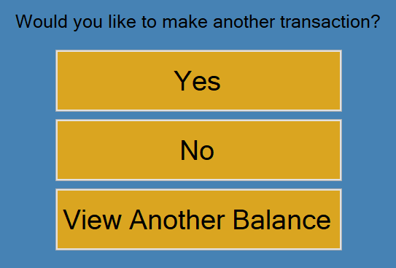

* + 1. If the customer selects the “Yes” button, the system shall return to the main menu screen.



* + 1. If the customer selects the “View Another Balance” button, go back to Step 4.3.



* + 1. If the customer selects the “No” button, the system shall log the customer out of the ATM and display a “Thank you” screen.



1. The system shall allow a customer to transfer money from his/her bank account to another bank account.
   1. The system shall display a main menu screen to the customer.



* + 1. If the customer selects the “Logout” button, the system shall log the customer out of the ATM and display a “Thank you” screen.



* 1. The customer shall select the “Transfer” button from the main menu.

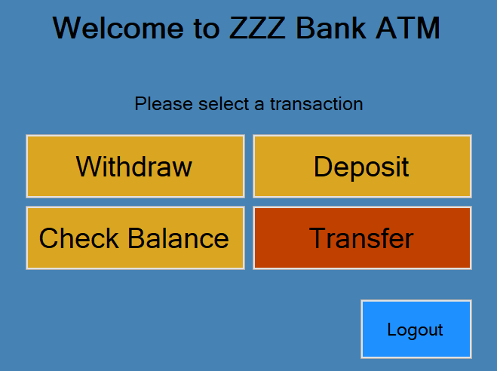

* 1. The system shall display a list of the customer’s accounts to transfer from.

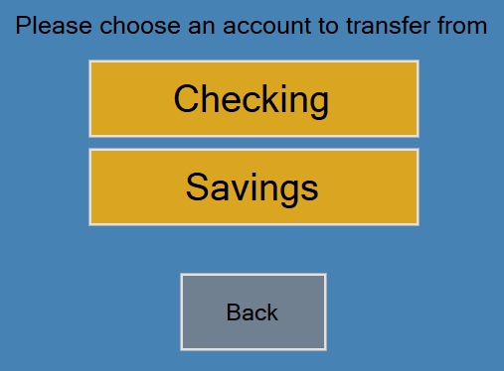

* + 1. If the customer selects the “Back” button, the system shall go back to Step 5.1.



* 1. The customer shall select an account from the list to transfer from.

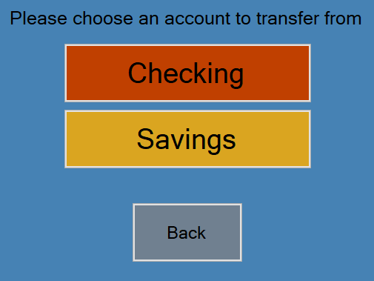

* 1. The system shall display the selected account’s information including the account number and current balance and an “Next” button for the customer to select after they have viewed the account information.

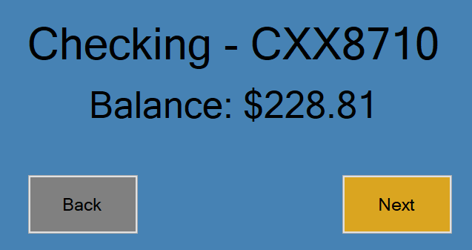

* + 1. If the customer selects the “Back” button, the system shall go back to Step 5.3.



* 1. The system shall display a menu screen asking the customer to choose what account they want to transfer money to.

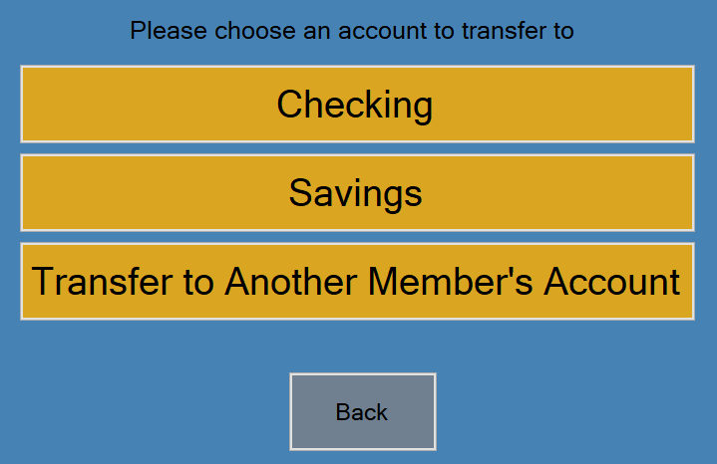

* + 1. If the customer select’s one of their own accounts, go to Step 5.7.
    2. If the customer selects the “Transfer to Another Member’s Account” button, the system shall display a menu asking the customer to enter the account number of the account they would like to transfer money to.

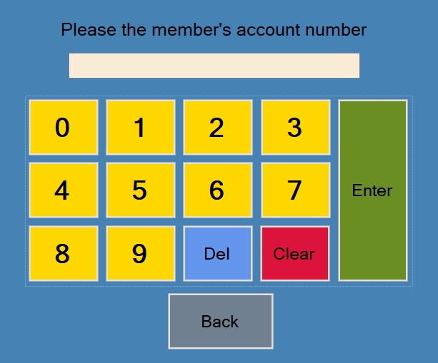

* + - 1. The customer shall enter the account number of the account they want to transfer money to.

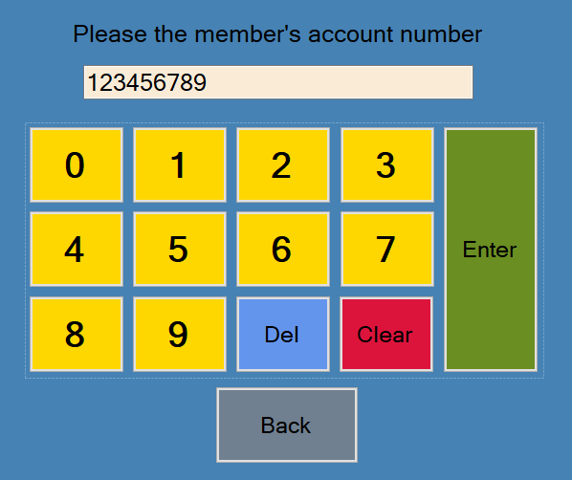

* + - * 1. If the account number is found in the database, go to Step 5.7.
        2. If the account number is not found in the database, the system shall display an error message and go back to Step 5.6.2.

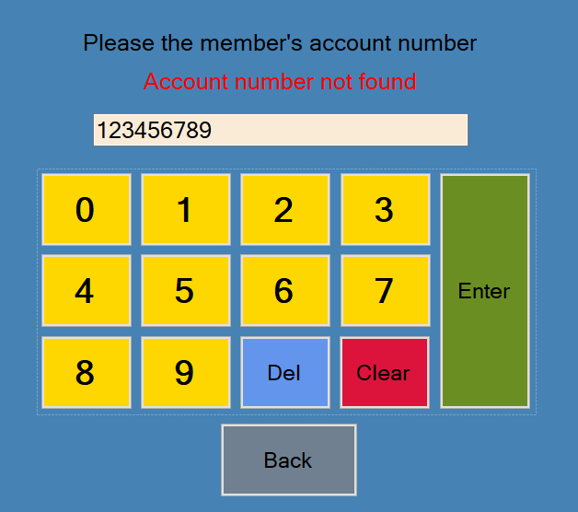

* + 1. If the customer selects the “Back” button, the system shall go back to Step 5.5.



* 1. The system shall display a menu asking the customer how much money they would like to transfer from their account to the one they selected to transfer to.

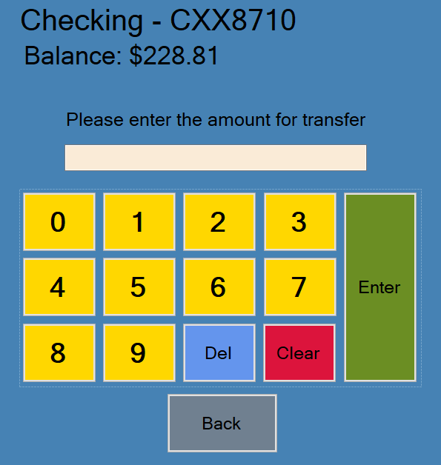

* + 1. If the customer selects the “Back” button, the system shall go back to Step 5.6.



* 1. The customer shall enter the amount to transfer.

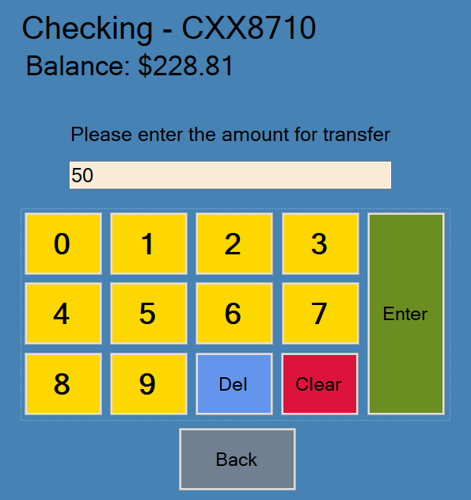

* 1. The system shall check if the amount satisfies NR9.
     1. If the amount being transferred from the customer’s account is greater than $3,000, the system shall display an error message and go back to Step 5.7.

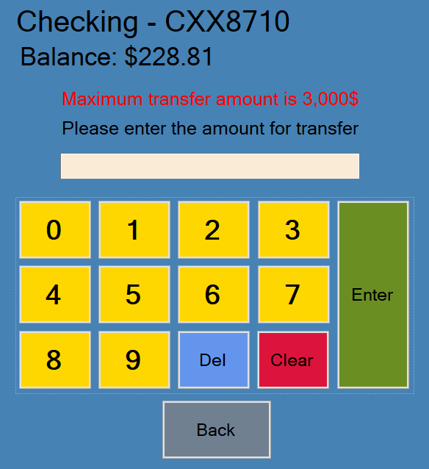



* + 1. If the amount being transferred from the customer’s account is less than or equal to $3,000, go to Step 5.10.
  1. The system shall check if the amount satisfies NR8.
     1. If the difference of the customer’s account balance and the transfer amount is less than $5, the system shall display an error message to the customer and go back to Step 5.7.

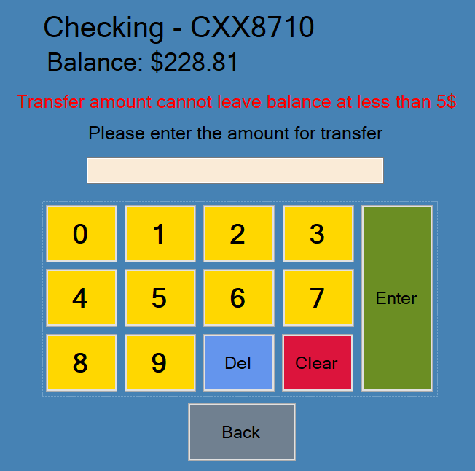



* + 1. If the difference of the customer’s account balance and the transfer amount is greater than or equal to $5, go to Step 5.11.
  1. The system shall check if the amount satisfies NR7.
     1. If the transfer amount plus any other transfers amounts made from the account during the current day come to a total greater than $3,000, the system shall display an error message to the customer and go back to Step 5.7.

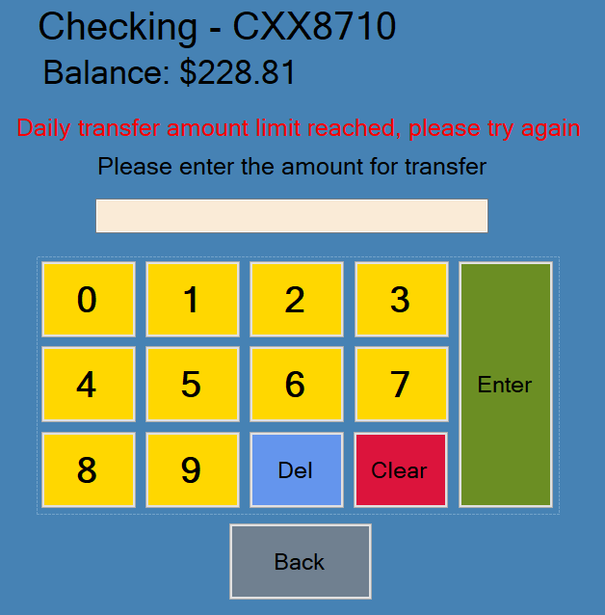



* + 1. If the transfer amount plus any other transfers amounts made from the account during the current day come to a total less than or equal to $3,000, go to Step 5.12.
  1. The system shall check if the amount satisfies the NR13.
     1. If the transfer amount is less than $5, the system shall display an error message and go back to Step 5.7.

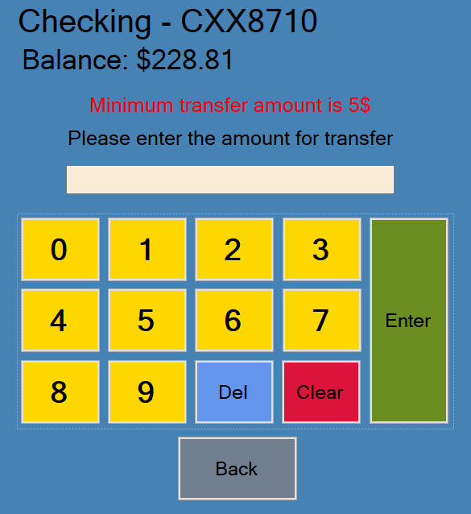



* + 1. If the transfer amount is greater than or equal to 5$, go to Step 5.13.
  1. The system shall record the transaction to the database.
  2. The system shall deduct the transfer amount from the customer’s account’s current balance and display the new balance to the customer.



* 1. The system shall add the transfer amount to the member’s account’s current balance that the customer selected.
  2. The system shall display a menu asking the customer if they want to make another transaction.



* + 1. If the customer selects the “Yes” button, the system shall return to the main menu screen.



* + 1. If the customer selects the “No” button, the system shall log the customer out of the ATM and display a “Thank you” screen.



## Non-functional Requirements

1. The maximum amount for withdrawal is $3,000.
2. The amount for withdrawal shall not leave the account balance of less than 5$.
3. The amount for withdrawal shall not exceed the amount of current available funds inside the ATM machine.
4. The maximum amount for deposit is $3,000.
5. The total of all deposit amounts made to the account during the current day shall not exceed $3,000.
6. The total of all withdrawal amounts made from the account during the current day shall not exceed $3,000.
7. The total of all transfer amounts made from the account during the current day shall not exceed $3,000.
8. The amount for transfer shall not leave the account that is being transferred from with an account balance of less than $5.
9. The maximum amount an account can transfer to another is $3,000.
10. The maximum number of allowed invalid PIN number entry attempts for a specific card number is 5 per day, after this a user can no longer attempt to log into that specific card’s associated account until the next day.
11. The minimum withdraw amount is 5$.
12. The minimum deposit amount is 5$.
13. The minimum transfer amount is 5$.

# Use Case Diagram

This use case diagram depicts all use cases of the ATM software system. On the left is the Customer actor which interacts with Check Balance, Withdraw, Deposit, and Transfer and there is also the User actor which interacts with the Login use case.

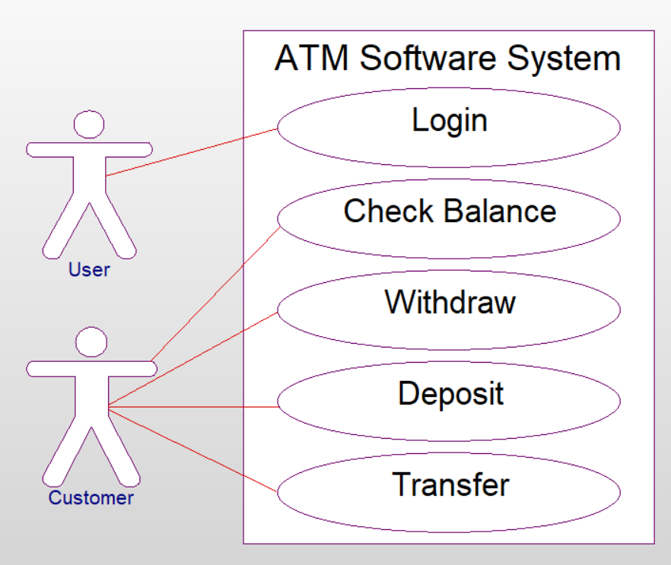

# Class Diagram

This Class diagram displays the classes of the software, the information they handle, and the operations they perform. The User class gets and stores the user’s information and uses it to log them in and then they become a customer. The Customer class stores the customer’s card number to be used with the Account class and Transaction class. The Account class is used to retrieve the information of the customer’s accounts and update it and uses it with the Transaction class. The Transaction class is used to perform transactions using the information from the Account class and stores the transaction information and updates the Account class information.

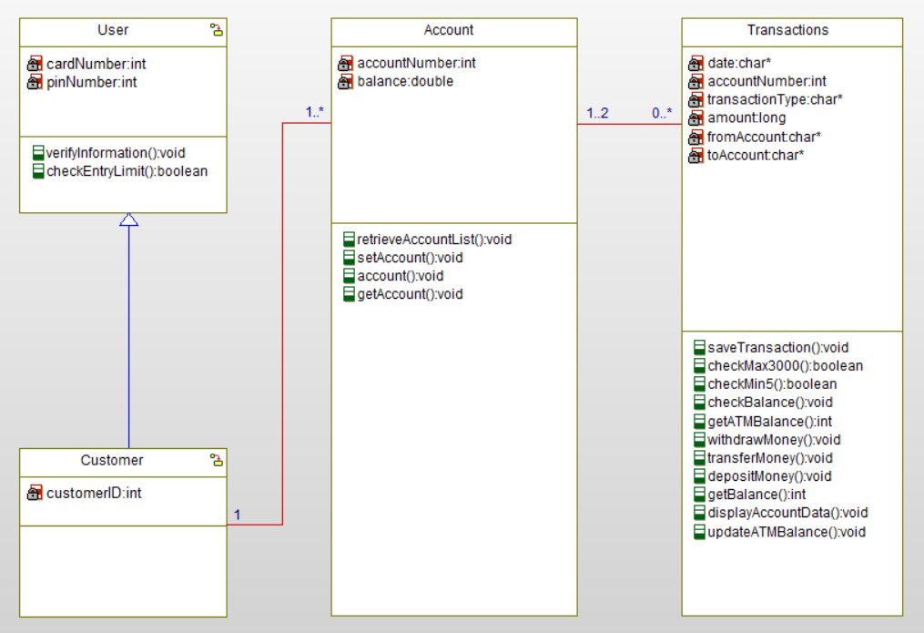

# Sequence Diagrams

## Login

The user enters their card number and the User class uses the verifyInformation() functions to check if the card number is valid. The user then enters their PIN number and verifyInformation() checks if the PIN number and card number match. If the verifyInformation() functions fail, the system displays an error message. If the verifyInformation() functions do not fail, the system will log the customer in and display the main menu.

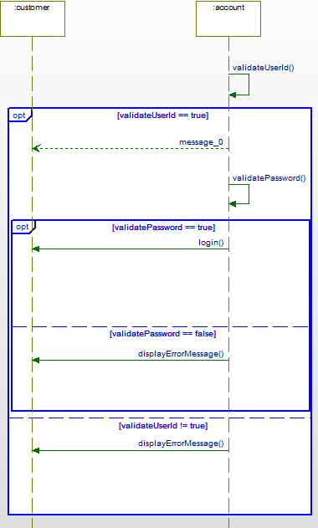

## Check Balance

The customer selects check balance from the menu and the system retrieves their accounts to display in a list. The customer may select any account and the selected account will be retrieved to display the balance.

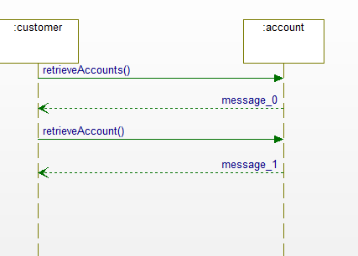

## Withdraw

When a logged in customer selects the withdraw button, they are presented with a menu to select an account. When the customer selects an account, the transaction class checks daily transactions and if the date of the last transaction is older than 24 hours, the transaction total is reset. The transaction class also checks to see if the ATM has enough balance, if the customer has enough balance, and if the amount is greater than 5 and less than 3,000 when the customer presses the enter button. If any of these functions fail, the system will display an error message. If all the functions do not fail, the transaction class will save the transaction and update the account class.

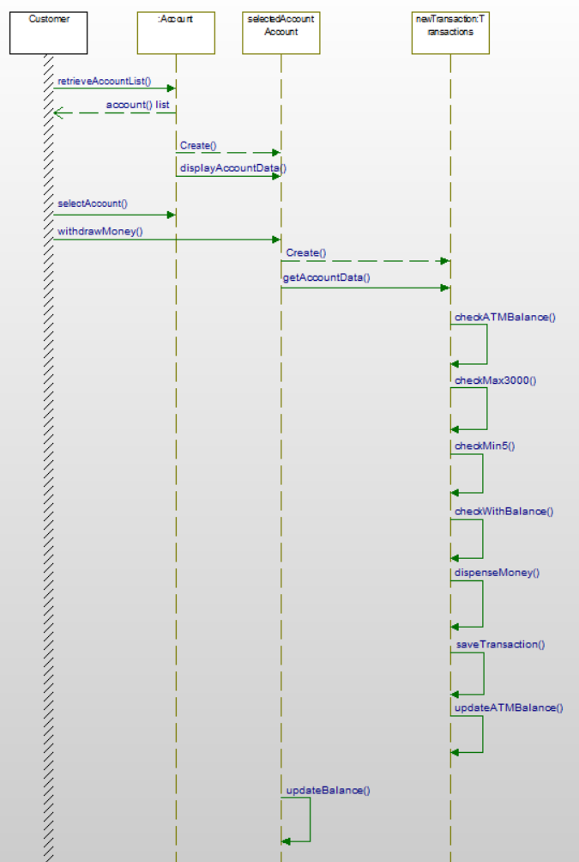

## Deposit

When a logged in customer selects the deposit button, they are presented with a menu to select an account. When the customer selects an account, the transaction class checks daily transactions and if the date of the last transaction is older than 24 hours, the transaction total is reset. The transaction class also checks to see if the customer has enough balance, and if the amount is greater than 5 and less than 3,000 when the customer presses the enter button. If any of these functions fail, the system will display an error message. If all the functions do not fail, the transaction class will save the transaction and update the account class.

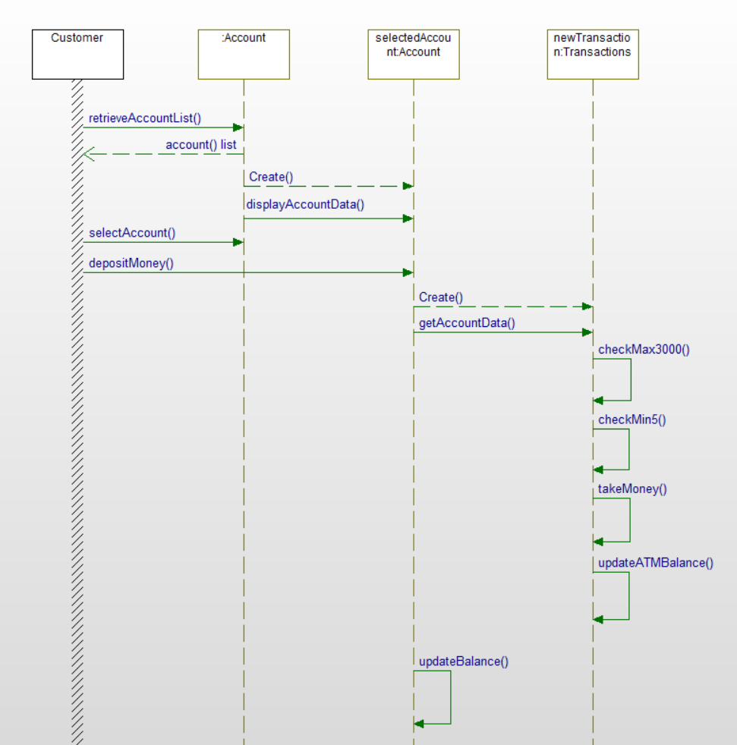

## Transfer

When customer selects transfer money, the system retrieves all accounts to choose from, then the customer can select an account to transfer from. This account will be retrieved, and the system will check to see if the date of last transaction is over 24 hours ago. If this is true, the system will reset the account’s transaction total. The system will then prompt the customer to choose to either transfer to one of their accounts or another member’s account, if they select to transfer to another member they will enter the card number of the member’s account they want to transfer to. The customer will then enter the amount they want to transfer and then both accounts will have their data updated on the database when the transferMoney function is called. A transaction is created and saved to the database as well.

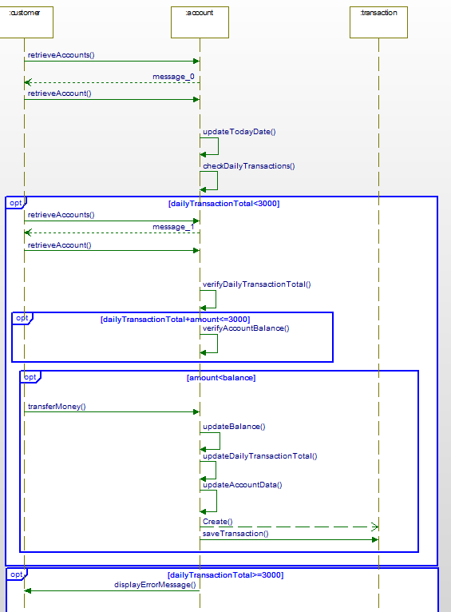

# State Diagrams

## Login

This state diagram describes the sequence of events involved with the login process.

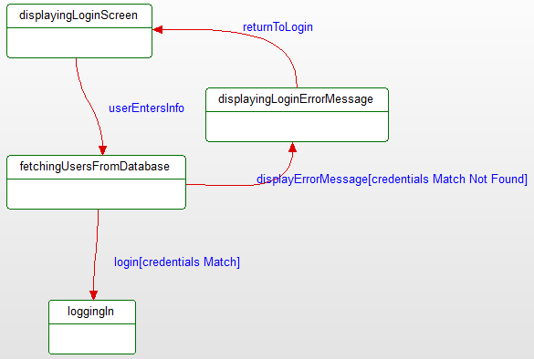

## Check Balance

This state diagram describes the sequence of events involved with the check balance process.

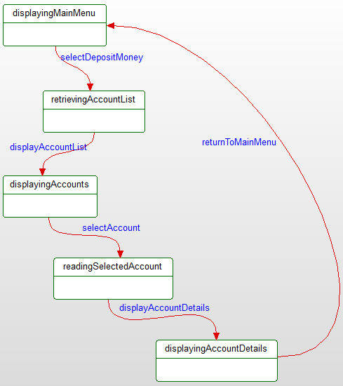

## Withdraw

This state diagram describes the sequence of events involved with the withdrawal process.

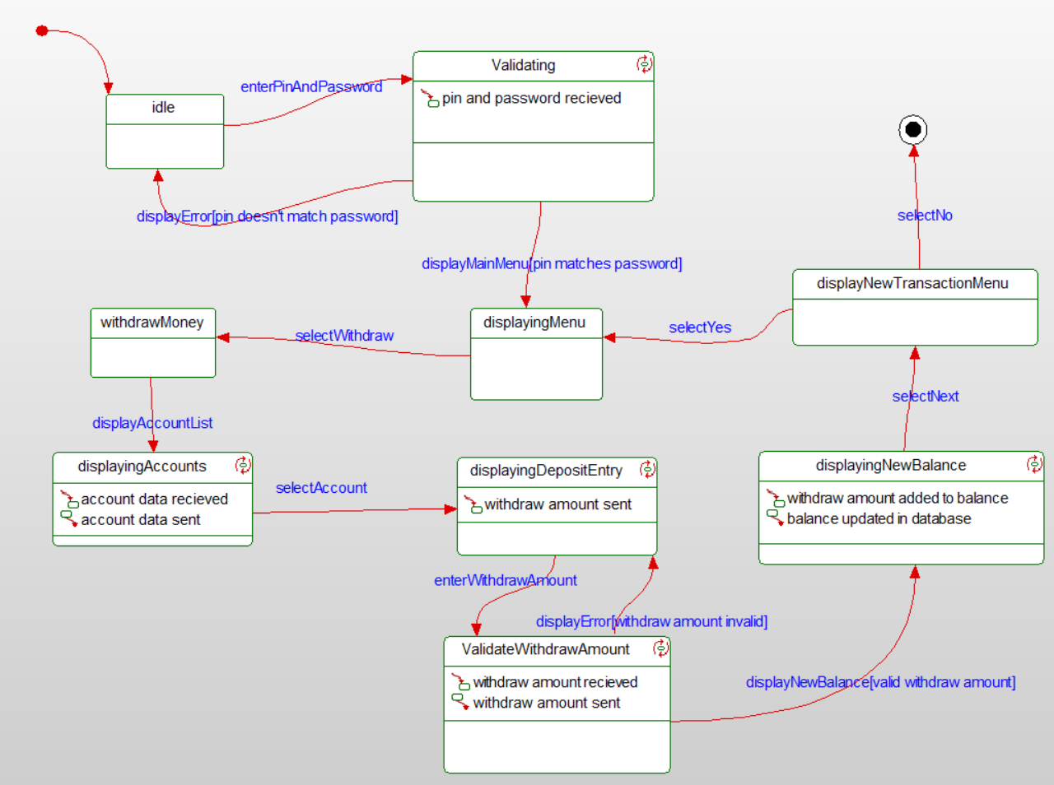

## Deposit

This state diagram describes the sequence of events involved with the deposit process.

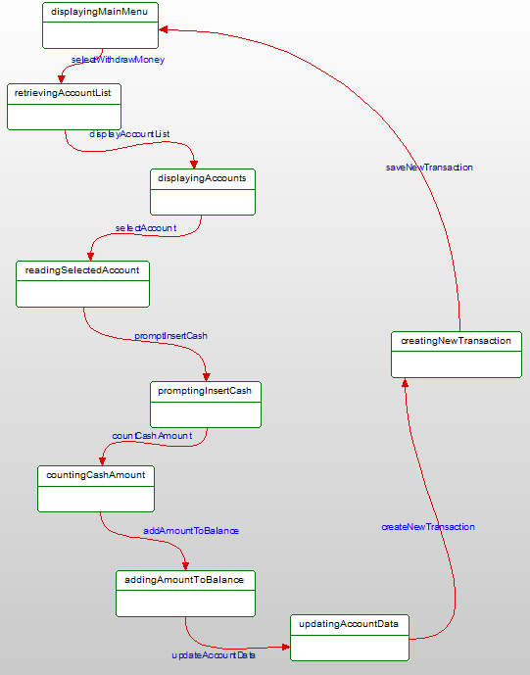

## Transfer

This state diagram describes the sequence of events involved with the transfer process.

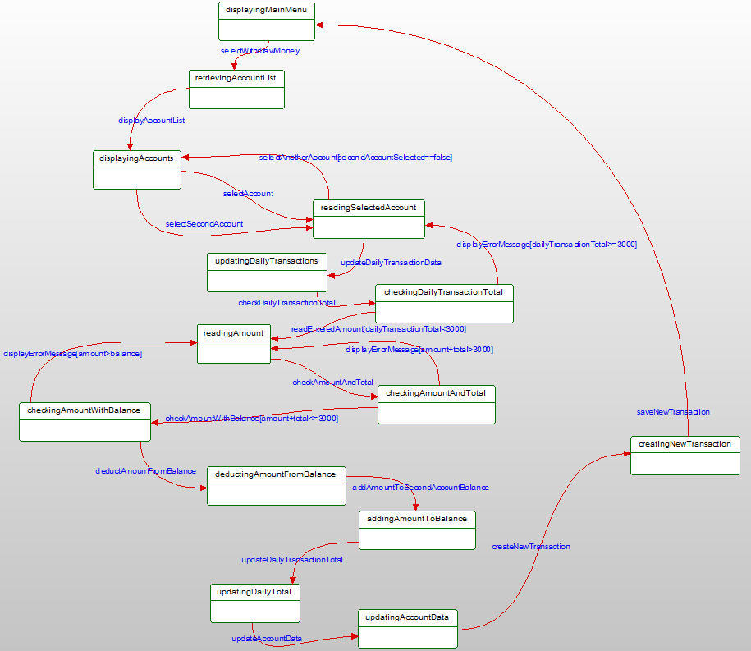

# Activity Diagrams

## Login

This activity diagram shows the flow of events involved in the login process. The flow begins with the user to the user class when the user begins using the ATM software system. The user will enter their information and the user class will store it and compare it to the data retrieved from the database. If the information the user entered is correct, they have become a customer and the main menu screen will be displayed to them.

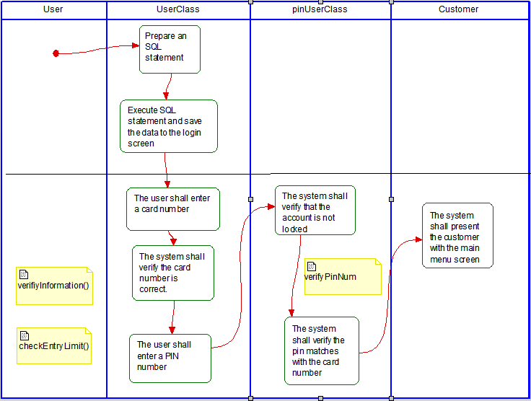

## Check Balance

This activity diagram shows the flow of events involved in the check balance process. The flow begins with the customer selecting check balance from the main menu and then the customer class sends a request to retrieve a list of the customer’s accounts from the database. The account class will display the account information to the customer after the customer selects an account.

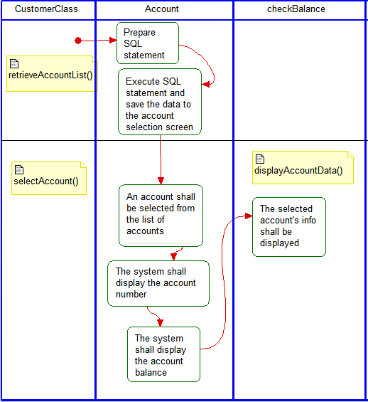

## Withdraw

This activity diagram shows the flow of events involved in the withdraw process. The flow begins with the customer selecting withdraw from the main menu and then the customer class sends a request to retrieve a list of the customer’s accounts from the database. The account class will display the account information to the customer after the customer selects an account. The customer will enter an amount to withdraw and the withdraw class will check to see if the amount meets the requirements and if it does it will dispense money to the customer and deduct the amount from the account balance and display the new balance to the customer.

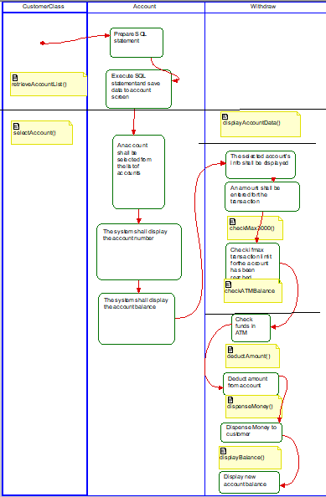

## Deposit

This activity diagram shows the flow of events involved in the deposit process. The flow begins with the customer selecting deposit from the main menu and then the customer class sends a request to retrieve a list of the customer’s accounts from the database. The account class will display the account information to the customer after the customer selects an account. The customer will enter an amount to deposit and the deposit class will check to see if the amount meets the requirements and if it does it will take money from the customer and add the amount to the account balance and display the new balance to the customer.

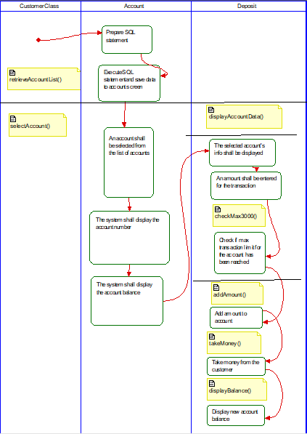

## Transfer

This activity diagram shows the flow of events involved in the transfer process. The flow begins with the customer selecting transfer from the main menu and then the customer class sends a request to retrieve a list of the customer’s accounts from the database. The account class will display the account information to the customer after the customer selects an account. The account class will display a list of accounts for the user to transfer to and the customer will select an account. The customer will enter an amount to transfer and the transfer class will check to see if the amount meets the requirements and if it does it will deduct the amount from the customer’s balance and add the amount to the selected account’s balance and display the new balance to the customer.

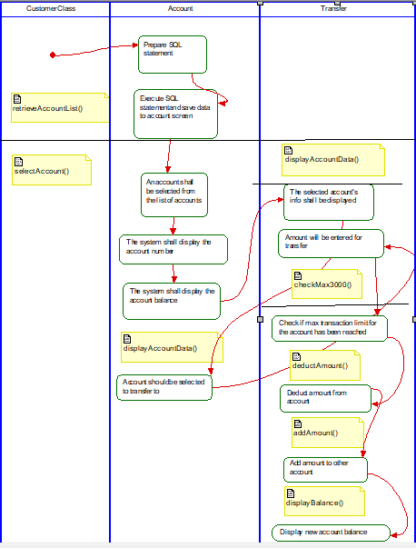

# Database Design

## ER Diagram

This ER Diagram shows the relationship between the different tables in the database and the variables they have.

## Table Schema

This ER Diagram shows how the different tables in the database access each other’s data and the variables they have.

# Conclusion

The ATM system was successfully created and meets all the requirements laid out in the design specification. The system can retrieve customer data from the database and use it to provide the required services to the customer, and it will accurately update the database with the new information. The system allows the customer to log into their account, deposit money from their accounts, withdraw money from their accounts, check the balances of their accounts, transfer money between their accounts and other customer accounts, and log out of their account. These are all essential functions expected of all ATM systems and the system can perform these tasks and includes other functions that make using the ATM safer and more secure for the customer, makes the ATM easier for ZZZ Bank to manage, and allows the required functions of the system to execute more efficiently and smoothly.

# Data Dictionary

* **Actor**: Actors are what initiates a *use case*. Actors are often people like customers or employees but can also be objects such as other systems.
* **Class Diagram**: Class diagrams represent an overview of the system, by describing the classes within the system and their relationships with each other.
* **Association**: An association is a relationship between instances of the two classes.
* **Aggregation**: An aggregation is an *association* in which one class belongs to a collection.
* **Generalization**: A generalization is an inheritance link indicating one class is a superclass of the other.
* **Scenario**: A scenario is what happens when an *actor* interacts with the system.
* **Sequence Diagram**: A sequence diagram describes how operations are carried out by the messages sent between objects. A sequence begins at the top of the page and progresses downward.
* **State**: A state represents what a system is doing at a point in time.
* **State Diagram**: A state diagram describes how the system transitions between *states.*
* **Activity Diagram**: An activity diagram is an advanced version of a flow chart that models the flow from one *activity* to another *activity*.
* **Activity**: An activity is an operation of the system.
* **Swimlanes**: Swimlanes determine which object is responsible for which *activity*.
* **Table Schema**: A table schema represents what the tables of a database should contain. The title of a row represents.
* **ER Diagram**: An ER Diagram is a type of flowchart that illustrates how “entities” such as people, objects or concepts relate to each other within a database system.
* **Use Case**: A use case is represented by an oval on the *use case diagram*. A use case represents a single task. Use cases are initiated by *actors*.
* **Use Case Diagram**: A use case diagram describes the behavior of a system from the perspective of a user. It describes simply what a system does. The ovals represent *use cases.* The images resembling people are called *actors*.